Assessing the effects of input support policies on intensive versus extensive margin supply growth in Tanzania’s dairy sector: implications for land use and net greenhouse gas emissions

James Hawkins

November 2017

1. **Introduction**

The dairy sector plays an essential role in livelihoods of the rural population in East Africa, providing a significant amount of cash income and nutrition for smallholders owning cattle. Omamo et al. (2006) shows that milk is the most important commodity for supporting GDP growth and poverty reduction in East Africa. In Tanzania, large ruminants dominate total milk production in the country, producing ~98% of all fluid milk (Mgeni and Salim Nandonde, 2012). The cattle population is comprised mostly of traditional herds of Zebu animals, representing >95% of total cattle (NBS, 2015). Despite this, the population of improved cattle produces a disproportionate quantity of milk: __ relative to __ from the traditional herd (NBS, 2015). Milk offtakes of Zebu cattle range between __ to __ l per day, which is far less than the biophysical potential under cross bred cows and with improved feeding management (Mruttu et al, 2016). Given that milk production and sale offers a higher return to investment compared to other livestock (Udo et al, 2015), the dairy sector is a crucial component of rural poverty alleviation efforts in the country (). The dairy sector also represents a major contributor to Tanzania’s national greenhouse gas (GHG) emission budget (). Thus, due to the important role of the dairy sector in rural poverty alleviation, as well as climate initiatives by the Tanzanian government, there is a need to identify low emission development pathways, allowing the dairy sector to develop concurrently with declining greenhouse gas emissions. Climate and development organizations are interested in providing financing to projects that show potential for these dual outcomes. In order to be implemented, low emissions development pathways must be shown to lead to verifiable and lasting emissions reductions, however, and to lead to improved livelihoods for the rural population involved in dairy production.

The literature has provided strong evidence that there exist synergies between efficiency improvement in the dairy sector, declines in emissions intensities, and improvements in income and nutrition based welfare indicators for dairy households. Bryan et al (2011) finds that improved feeding practices and soil fertility management lead to both lower emissions intensities and higher profitability for milk producing households across the central Kenyan highlands. Shikuku et al (2017) consider feeding practices and adoption of crossbred cattle in Lushoto, Tanzania, and find that these practices reduce emissions intensities across household types. Paul et al (2017) considers crossbred cow adoption, mineral fertilizer application, and improved feeding in relation to farm GHG emissions and household food availability in Rwanda, and propose that feeding is most essential to reaching the CSA triple win[1]. Using the GLEAM model for mixed dairy systems in East Africa, Mottet et al (2015) estimate that improved feeding and herd management can reduce emissions by up to 13% with growth in output up to 18%, and up to 31% with constant output. Further, when the reductions in land use from improved productivity is considered, the same holds true. Bosire et al (2016) estimate that intensification of the feed crop sector can reduce total land requirements (sum of feed crop and grazing land) by up to 40% for the livestock sector in Kenya. In studies that specifically quantify the impact of reductions in land use and sparing of land with naturally high carbon (C) content in sub Saharan Africa), the implications of spared and/or set aside land is highlighted as a critical factor in the climate impact reductions of different livestock development scenarios (Havlik et al, 2014; Valin et al, 2013).

Because of these findings, policy efforts have oriented around providing the needed inputs to intensification at low cost, in order to reduce land occupation and achieve emissions intensity reductions (______ ), as well as improving supply chain efficiency and reducing marketing margins, to increase the returns for dairy producers (). However, promoting input intensification and commercialization of the dairy sector as an emissions mitigation strategy leads to growth in total milk production, brought about by higher returns and income (and hence consumption) for dairy producing households (Valin et al, 2013; Bryan et al, 2011, Shikuku et al, 2017, Paul et al, 2017). This presents a fundamental challenge for efforts to simultaneously mitigate gross GHG emissions from the dairy sector while improving food security and rural livelihoods.

This study considers the role of supply side policy interventions in relation to the volume of milk produced for home consumption and sale, the decisions with respcect to stocking rate, and land use, for smallholder dairy producers in the Tanzanian southern highlands. Mathematical programming is a powerful tool for conducting positive analysis[2] of farm level decision making. Such models can assess decision making under alternative market or policy scenarios, and identify the factors determining households’ resource allocation of land, labour, and capital subject to competing commodities, subject to the objectives of the household. A mathematical programming model is used to assess ex ante the influence of policies with respect to prices of replacement dairy cattle, supplemental feeds, and the farm gate milk price, on the degree of intensification in dairy production. By considering the role of input support on total milk production, the impact of the policy framework on both aggregate emissions and emissions intensities is taken into consideration. The framework therefore provides needed insight into the trade-offs associated with meeting Tanzania’s national milk production targets, with competing goals of climate change mitigation.

1. **Methods**

**2.0 Overview**

The aim of the modelling framework is to assess the impact of input and output markets on the volume of milk produced (sum of home consumed and marketed milk), intensity of input use in dairy production, total grazing land requirements, and welfare proxies, including household income and nutrition security (Figure 3). Based on an analysis of a household survey in Lushoto (north-coastal region of Tanzania), Hammond et al (2017) find that the climate smartness of different farm strategies or interventions is strongly influenced by the characteristics of the farm household. Different household types are found to have different farming strategies, level of intensity, and therefore GHG emissions intensities. The authors conclude that identifying thresholds of farm size or livestock ownership for defining specific climate interventions is a needed research goal. Therefore the research goal of the present study is to assess how household characteristics (both biophysical and socioeconomic) influence the baseline emissions intensity, and the response to a given policy intervention.

Figure 3: Analytical framework for farm-household level ex ante analysis

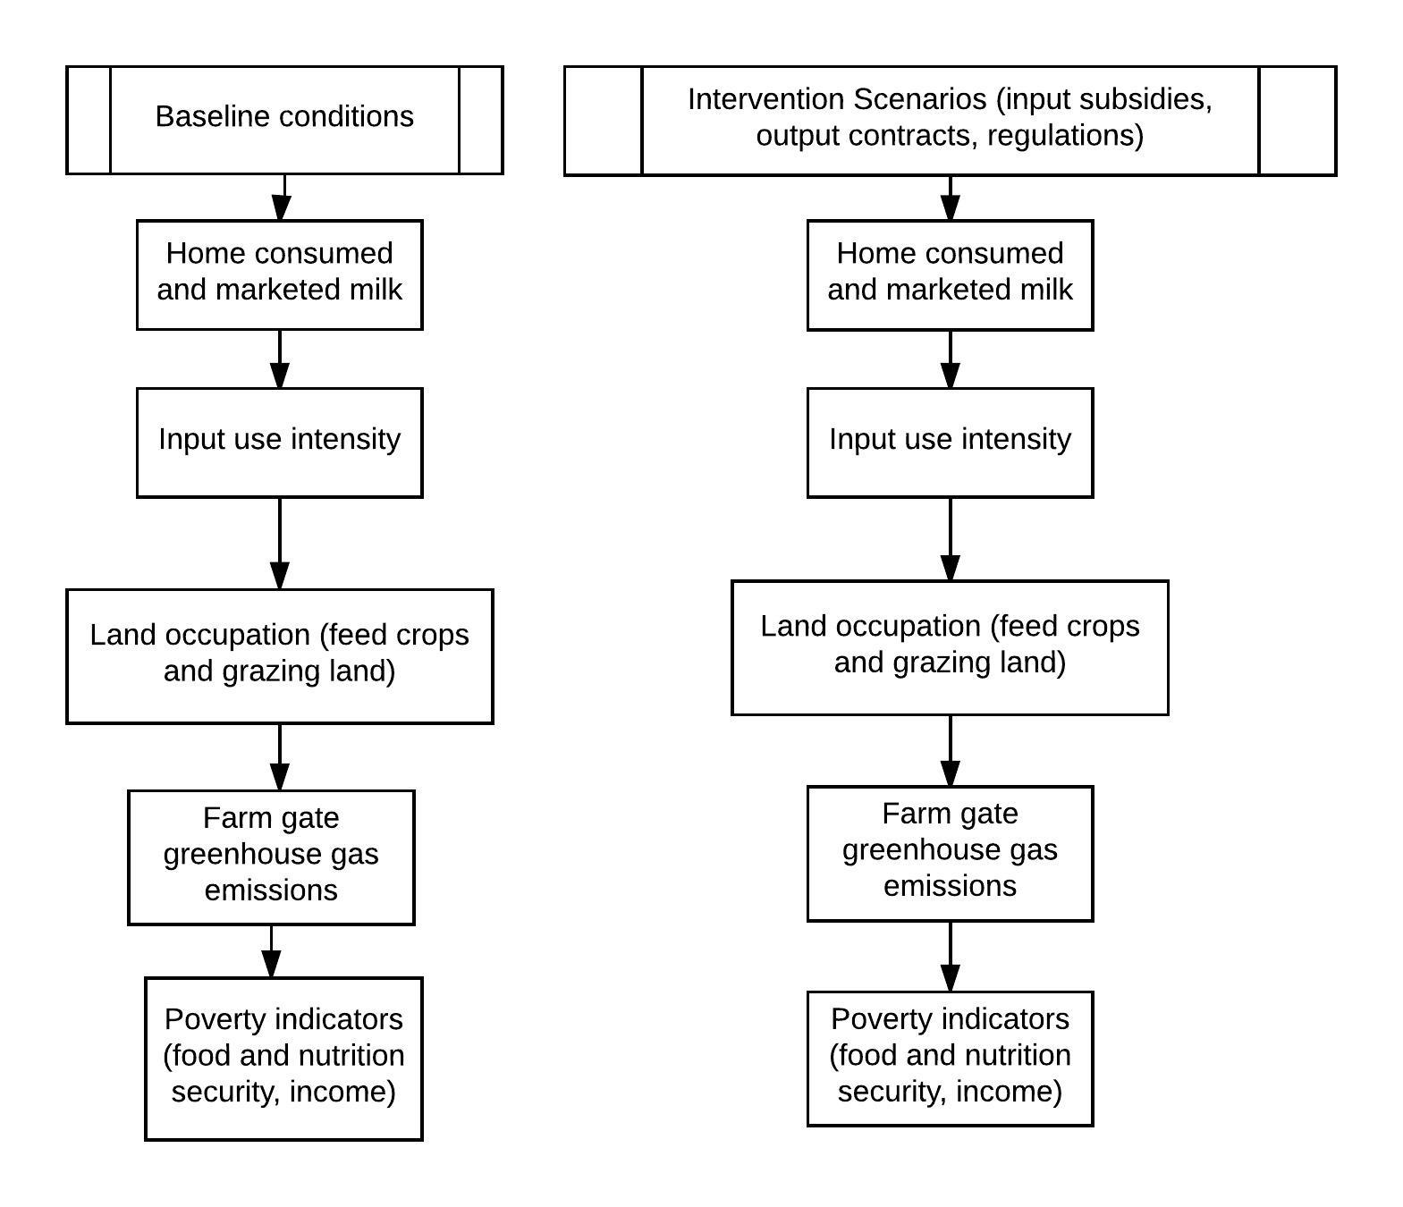

There exist comprehensive quantitative analyses of the climate impact and mitigation strategies of smallholder dairy in East Africa, extending from household level (e.g. Shikuku et al, 2017, Paul et al, 2017) to regional level (Mottet et al, 2015). Further, throughout sub-Saharan Africa, smallholder subsistence agriculture is acknowledged as a primary driver of deforestation and a contributor to forest degradation (Hosonuma et al, 2012). In Tanzania specifically, emissions from deforestation and forest degradation have been estimated at 70% of total land use GHG emissions (Carter et al, 2015), of which the dairy sector contributes from cattle grazing in forested areas, as well as direct deforestation for feed production and pasture. Overall the dairy sector’s contribution is estimated at ~20 % (refer here to Rosa’s study on spatial attributions of forest disturbance to different causes). Therefore, two distinct drivers of forest disturbance are considered:

1. temporary cattle grazing in shrub, wood, and forest land (resulting in CO2 emissions from forest degradation), and
2. the clear cutting of shrub, wood, and forest land for (permanent) crop and/or pasture production, resulting in CO2 emissions from deforestation (hereafter, deforestation).

The relative impact of the above two forest interactions in relation to the net GHG emissions intensity of milk production on farm is considered for each simulation analysis.

The inputs and policy interventions which form the basis for the simulation analysis are breeds and feeds. The rationale for focussing on these two intervention methods is quite strong. Graded cattle make up 3-5% of the total cattle population in the southern highlands (NBS, 2015), and increasing the population of improved cattle in the national herd ranks high on the government’s efforts for improving productivity of the dairy sector (). Low energy and protein density of feeds, and high seasonality in feed production, is also a major constraining factor (). A two-pronged strategy based on improved genetics and feeding is therefore a promising approach for improving milk productivity and achieving sectoral climate reduction goals. For the purposes of the framework herein, changes in grazing land requirements are calculated based on the average pasture yield of different types of grazing land specified by the modelled households (including rangeland, grasslands, marginal land such as river and road sides, and forest) and the required forage dry matter intake needed to sustain the herd. Welfare proxies are based on income (sum of farm income, which includes crop and livestock sales, and off farm income), and household food and nutrition security. [Describe how food and nutrition security are considered].

The model design is intended to capture the long term, dynamic effects of management changes on the productivity of the dairy enterprise, which includes changes in the herd structure. Of these processes, the influence of dietary quality improvement for young animals on lifetime milk productivity and demographic structure is considered. Lifetime milk yield and herd demographic structures (e.g. the proportion of producing to non-producing animals in the herd) are key factors of productivity of dairy production and hence dairy emissions intensity (Rufino et al, 2009; Bebe et al, 2002). Further, the influence of adoption of crossbred cows in relation to the maximum potential milk yield is considered, as crossbreds can achieve maximum potential milk yields more than double that of indigenous cattle (Mruttu et al, 2016).

[will discuss additional important technical aspects of framework here]

The household model is developed in the General Algebraic Modelling System (GAMS); a software package useful for developing optimization and simulation models for (Brooke et al, 2008). The model parameters are from household survey data gathered in the Tanzanian southern highlands milkshed region during the years 2017-2018 [list the names and affiliations of the surveys]. The administrative regions covered by the survey include Mbeya, Iringa, Morogoro, and Dodoma (Table 1). [Discuss basic agro-ecological and geographic conditions of region, including major markets for inputs and outputs, population, incomes].

[discuss the method for developing clusters or stratifications of households]

Table 1: Site statistics

|  |  |  |  |  |  |
| --- | --- | --- | --- | --- | --- |
| Region | Agro-ecologies | Number of households | Population density | Average altitude | Average precipitation |
| Mbeya |  |  |  |  |  |
| Iringa |  |  |  |  |  |
| Morogoro |  |  |  |  |  |
| Dodoma |  |  |  |  |  |

Sources: NBS (2015)

Table 2: Income, resource endowments, household dependents, degree of market orientation, and input use by household

|  |  |  |  |  |
| --- | --- | --- | --- | --- |
| Parameter | Household types | | | |
|  |  |  |  |
| Food Crop only – Local Cows | Cash and food crop – local cows | Food crop only – improved cows | Food and cash crop – improved cows |
| Land holdings (ha) |  |  |  |  |
| Cattle holdings (hd) |  |  |  |  |
| Household members  (people) |  |  |  |  |
| Annual marketed milk surplus  (kg yr-1) |  |  |  |  |
| Off farm income  (Tsh yr-1) |  |  |  |  |
| Input Use | | | | |
| Breeding  Method | Sexed semen | Sexed semen | Artificial Insemination | Artificial Insemination |
| Expenses on breeding and health services  (TSh hh-1 yr-1) |  |  |  |  |
|  |  |  |  |  |
|  |  |  |  |  |

Sources: Surveys

Notes: All values are means of sample stratification.

*Assessment of Policy Effectiveness*

The cost effectiveness of the input support policies considered with respect to the dual policy objectives of rural poverty alleviation and GHG abatement, respectively, are calculated as follows:

1. The cost-benefit ratio (CBR) of a given input subsidy is defined as the public cost of the policy with respect to the change in value of milk production caused after the policy is implemented. The public cost of the policy is defined as the change in mean input price for a given region multiplied by the change in aggregate consumption of inputs for a given region, r. This is meant to assess the effectiveness of the policy with respect to rural poverty alleviation:
$${CBR}_{i,r}= \frac{∆{ (Mean Input Price_{i,r} ×Quantity of Inputs }_{i,r})}{∆ {(Value of Production}_{r})}$$

2. The cost effectiveness of the policy with respect to greenhouse gas mitigation. This is meant to assess the effectiveness of the policy with respect to abatement.

CEi,r

Where CEi,r is the cost effectiveness of the input support policy with respect to greenhouse gas mitigation (TSh Mg CO2eq yr-1).

* 1. **Ex Ante Analysis of Input Support Policies at Household Level**

**2.1.1 Household simulation model**

The following section presents the framework for the household mathematical programming model. For a more complete listing of model equations, see Appendix B. A flow diagram of the conceptual framework for the household systems analysis is presented in Figure 1. The household model maximizes a risk adjusted utility function based on the discounted value of future cash income from the farm enterprise, the value of cattle assets, and home food consumption (Appendix B.1). Home food production and food expenditures are non-separable; expenditure on food consumption is determined using a linear expenditure system (Louhichi and Gomez y Paloma, 2014), with own price and income elasticities of food demand based on Chongela et al (2014). Off farm sources of income, including employment income, remittances, and pensions, are assumed exogenous and fixed. The model operates on a recursive inter-temporal optimization framework; the objective function is executed sequentially on a one year time step, over a multi-year time period. This dynamic, recursive inter-temporal framework allows for the lagged impacts of interventions on the household to be considered. Milk offtake of the dairy enterprise is an endogenous function of the underlying dynamics with respect to herd composition and lactation milk yield for adult females. The choice variables are the allocation of available crop land to different types of food, cash, and fodder crops, as well as the choice of input intensity for the dairy enterprise. Two inputs are considered, namely the purchases of local and improved replacement cattle, and supplemental feeds purchased at market prices. The choice of home fodder production for feed is also endogenous and subject to the resource constraints of the household (land, labour, and capital). The land holdings are based on the household’s specification of owned and rented land in the household survey. Labour constraints are equal to the total labour availability from household members plus hired in labour paid at market wage rates. A cash constraint specifies that the total expenditure on farm inputs in a given period is equal to total cash income for the household minus farm and non farm expenditures. Non farm expenditure is divided into two categories: food and non-food, with the amount spent on each based on the linear expenditure system (Appendix B.4).

Availability of labour has been cited as a major constraint to home production of fodder crops, as well as gathering, storing, and supplying feed to animals in confinement, in smallholder systems in East Africa (Ogle, 1991). In the survey, we chose a subset of households to develop comprehensive labour schedules for cattle rearing and crop production, disaggregated by activity, month, and source of labour (home versus hired). For livestock, labour requirements were differentiated between households grazing livestock and households which keep animals in confinement based housing systems. A labour balance equation (Appendix B.3 – Labour Balance) specifies that all labour requirements for cropping and livestock activities is met by home and hired labour in each month. The availability of land for cultivation is based on the survey specified land holdings of the household, which is defined as the land for which the household has ownership, plus the amount rented in. Since households often source forage and pastureland for grazing off farm (including neighbour’s land, communal land, and government land), the total grazing land required to meet the animal’s needs are estimated based on the number of cattle owned and their grazed forage intake, as well as the yield of different types of pasture land (Appendix B.5). Land acquisition/rental are included by specifying the purchase price and rental rate of land as an exogenous variable. Land prices and rental rates were determined by consulting village level authorities (GLBS, 2018). Availability of cash and credit for has been cited as a potential factor contributing to lack of investment in productivity improvement for smallholder dairy systems (Udo et al, 2015), especially the purchase of crossbred dairy cattle (Gerber, 2007). Therefore, we consider the stocks and balances of cash using a household cash balance equation. The role of credit availability is included in this equation by specifying that in a given period, cash can be obtained subject to a fixed repayment schedule in subsequent time periods (Appendix B.2). Calorie availability and nutrition diversity is calculated by […]

[additional model features get described here;]

Figure 1: Systems diagram of farm household

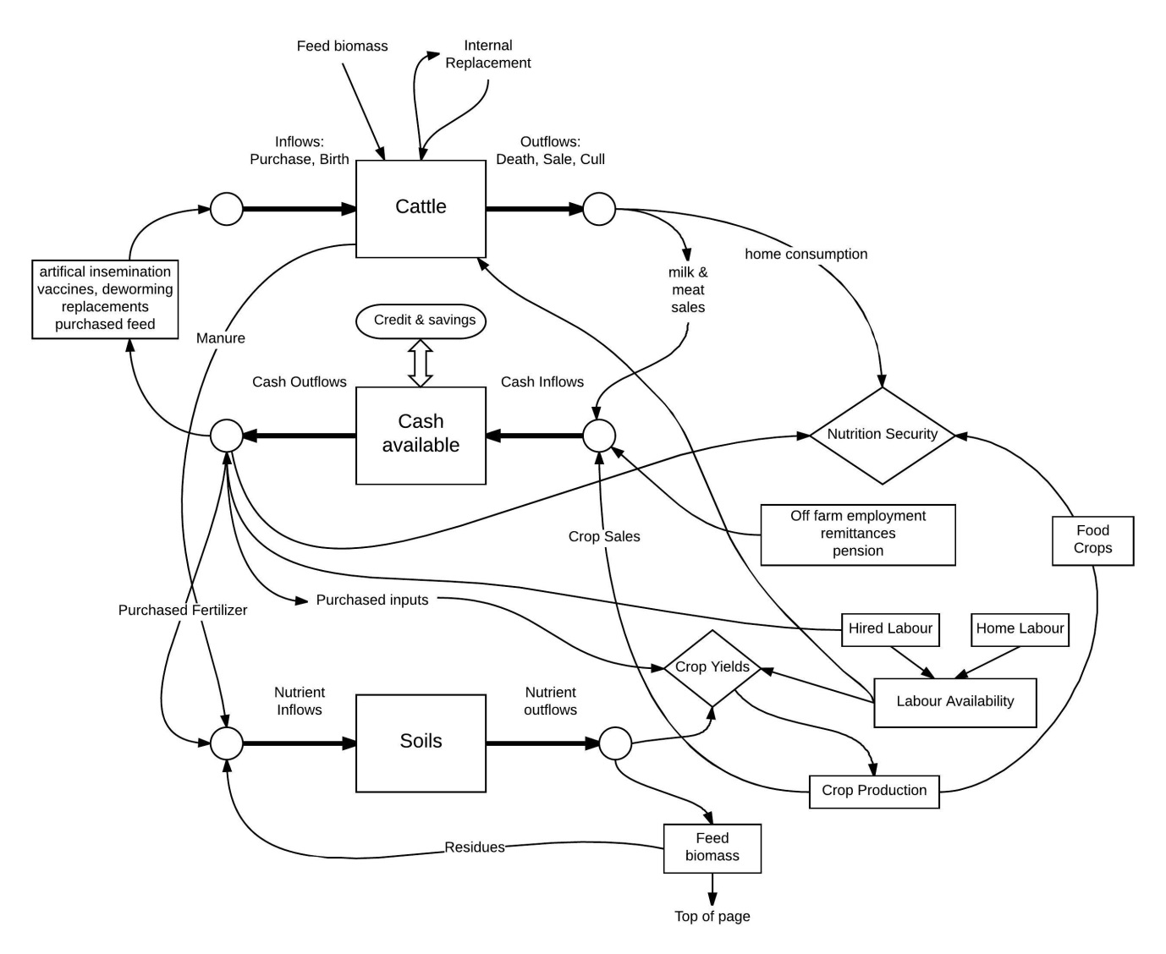

**2.2.2 Cropping and Grazing**

Dairy households in the Tanzanian southern highlands produce food and fodder crops for food and feed, as well as cash crops for sale (Table 4). For the baseline analysis, the absolute amount of land dedicated to food, fodder, and cash crops, as well as the yields, labour inputs, and purchased inputs was determined based on the household questionnaire (GLBS, 2018). The simulations treat land allocation between food, fodder, and cash crops as endogenous variables.

[additional aspects of cropping practices; rotations, yields]

The majority of households in the region practice semi-zero grazing, and therefore the supply of biomass for cattle is dependent on the quantity supplied during stall feeding, and the quantity grazed. The quantity of purchased feed, and the household’s land allocation between fodder crops, pasture, food and cash crops, and rangeland determines the availability of biomass. Food and cash crops are a source of crop residues for livestock feed. [specify the proportion of residues used as feed versus soil fertility management]. Pasture is distinguished from rangeland in that pasture land involves cultivation, including sowing, fertilizing, and harvesting, whereas rangeland is exclusively grazed. Many households specified having a degree of seasonal scarcity in forage availability, leading households to herd cattle long distances from the homestead in search of grazing resources. The area of land required for grazing was calculated based on the level of pasture intake needed in addition to the feed provided during stall feeding in order to meet the maintenance energy requirements of the herd (Appendix B.6).

**2.2.3 Dairy cattle**

A livestock simulation sub-model (module) accounts for quantity of cattle by cohort, and the milk offtake per adult female. Cattle are disaggregated by breed (local and improved), sex, and age. The cohorts include male and female calves, heifers, steers, cows, bulls, and castrated adult males. The module runs on a monthly time-step and considers the influence of feed quality and quantity on live weight gain for growing animals and milk yield of adult females for local and improved cattle. This approach is adopted in order to consider the full extent of herd level productivity improvement from feeding and adoption of improved breeds. Feeding higher quality diets in early life can reduce time to sexual maturity, and hence reduce the age of first calving, and increase the total number of calvings and lactations per adult female (Rufino et al, 2009). Animal numbers for each cohort in each period are determined using stage structured equations which consider the amount of animals moving into and out of a given cohort in each period, and is dependent on the calving interval, mortality rate per cohort, culling due to old age, growth rate, purchases, and sales[3]. The growth rate of young animals (calves, heifers, and steers) is dependent on the dietary energy supply for growth provided in each period. Purchases and sales are endogenously determined. All other parameters are specified based on survey data. A more complete description is provided in Appendix C.

The above factors, as well as reproductive management and preventative health interventions, have been proposed as measures that influence emissions intensity of smallholder dairy systems in East Africa (Mottet et al, 2015). Due to lack of epidemiological data on animal mortality and cost data on breeding, the impact of preventative health measures on animal health/mortality, or of interventions on the efficiency of breeding (i.e. from artificial insemination in place of natural breeding, and reducing the need for breeder males), are not considered. [basic production practices of dairy enterprise; culling management with respect to males]

Table 3: Baseline production parameters for local and improved cattle

|  |  |  |
| --- | --- | --- |
| Parameter | Local | Improved |
| Daily live weight gain 1,c(kg hd-1 d-1) | 0.25-0.9 | 0.25-0.9 |
| Calving rate 1,c (calves born per adult female per year) | 0.2-0.9 | 0.2-0.9 |
| Maximumlifetimed (years) | 13 | 13 |
| Calf mortalityc (%) | 0.25 | 0.25 |
| Heifer mortalityc (%) | 0.13 | 0.13 |
| Cow mortalityc (%) | 0.07 | 0.07 |
| Age to maturity1,c (first calving)(months) | 18-24 | 18-24 |
| Milk yield per adult female1,c (kg hd-1 d-1) | 4-12 | 7-16 |
| Mature weight1,a (kg hd-1) |  |  |
| Feed intake1,2 (kg DM TLU-1 d-1 ) |  |  |
| Selling price – steers and bullsb (Tsh TLU-1) |  |  |
| Purchase price – adult femaleb(Tsh hd-1) |  |  |
| Purchase price – heiferb(Tsh hd-1) |  |  |

Notes:

1Values shown are ranges to account for the variation between management and household types.

2 Feed intake per animal is a combination of supplemental feeds provided during stall feeding and *ad libitum* feed intake during grazing

Sources:

a Mruttu et al (2016)

b GLBS (2018)

c Calculated

d Bebe et al (2003b)

Table 4: Baseline production parameters of cropping enterprisea

|  |  |  |  |  |  |  |
| --- | --- | --- | --- | --- | --- | --- |
| Crop | Purpose | Yield  (Mg ha-1)  (SD) | Area  (ha) | Labour Inputsb  (peson-days month-1) | Non-labour input cost (Sh ha-1) c | Sale price  (Sh Mg-1)  (SD) |
| Maize | Food and sale | -- |  |  |  |  |
| Beans | Food and sale |  |  |  |  |  |
| Tea | Sale |  |  |  |  |  |
| Banana | Sale |  |  |  |  |  |
| Other cash crops | Sale |  |  |  |  |  |
| Napier | Fodder |  |  |  |  |  |
| Other fodder crops | Fodder |  |  |  |  |  |

Notes:

a Values are means for entire sample population

b Values listed are average for entire growing season. For month specific labour inputs, see supplementary material.

c Non-labour inputs include seeds, fertilizer, pesticides, herbicides, machinery.

**2.2.5 Farm level greenhouse gas emissions**

Farm gate greenhouse gas emissions are considered using the methodology of the Intergovernmental Panel on Climate Change (IPCC, 2006) Tier 2 approach. The farm gate emissions intensity of milk production is expressed as kg of CO2eq emissions per kg of fat and protein corrected milk (FPCM). This is estimated by summing all farm level sources and sinks of emissions and dividing by annual milk production. The following emissions categories are considered: CH4 from enteric fermentation, CH4 and N2O from manure, and N2O from feed crop production. Since the focus was on the influence of management on emissions intensity of the dairy enterprise, only N2O emissions from feed crops used as dairy feed were considered (food and cash crop emissions are excluded). Changes in total crop land on farm has implications for C emissions from land use change. Therefore, emissions associated with conversion of land to cropland is considered using the stock change approach (IPCC, 2006). C storage values for grassland, cropland, and forest in Tanzania are obtained from Pfeiffer et al (2012). [specify assumption about what type of land gets converted to cropland]. Further, as described above, the change in grazing land requirements is calculated for each simulation by determining the change in the amount of land needed to meet the pasture intake of the herd. The implications of declining grazing land requirements for the farm level GHG budget is estimated probabilistically by the amount of land that undergoes rehabilitation when it is no longer needed for grazing. To account for the variation in the type and degree of degradation of grazing land, the grazing land arrangements by households was obtained from the household survey. For a comprehensive description of the estimation of farm level greenhouse gas emissions, see Appendix D.

**2.2 Interventions**

From a series of stakeholder interviews, cattle genetic potential and quality of feed ingredients were two commonly cited constraints to productivity improvement in Tanzania’s dairy sector. Furthermore, the government of Tanzania has longstanding policies in place aimed at increasing the availability of crossbred cows and AI services providing semen from improved bulls. Therefore, the input support policies focus on these two types of inputs. Further, in the analysis by ______, credit availability was shown to be the single most important factor in adoption decisions of crossbred cows in Tanzania’s dairy sector. Therefore credit availability is considered by varying both the availability of loans and the interest rate.

1. **Results**
   1. Model Validation

Validation of the model involves comparing observed herd sizes and composition, milk offtake, and land allocation in the study region to the endogenously determined values from the model. This ensures that the model reproduces the production characteristics of dairy producers given the same exogenous factors.

* 1. Intervention scenarios

The intervention scenarios are changes in market prices of improved replacement cattle, market prices of supplemental feeds, and the interest rate of loans taken out for investment in the dairy enterprise. Further, these three intervention scenarios are assessed under changes in the farm gate milk price.

The total farm milk production, land use (total feed crop land and grazing area for dairy), farm gate greenhouse gas emissions intensity of milk, household income, and household nutrition security are presented for each scenario.

1. **Discussion**

Tanzania’s livestock policy has since 1984 focussed on improving input support for small scale as opposed to large scale farmers (Kurwijila, L.R and K.J. Boki. 2003). Is this the most efficient way of improving the productivity of the sector? Are there tradeoffs between efficiency and equity, and can they be quantified?

**5.0 Conclusion**

**References**

Charles Peter Mgeni and Salim Nandonde (SUA). 2012. Targeting dairy value chains in Tanzania: Process towards benchmark survey.

Bebe.

Bebe BO, Udo HMJ, Rowlands GJ and Thorpe W. 2003b. Smallholder dairy systems in the Kenya highlands: cattle population dynamics under increasing intensification. Livestock Production Science 82, 211–221.

Brooke, A., D. Kendrick, A. Meeraus, R. Raman. GAMS: A User's Guide. Release 2.50 The Scientific Press, Redwood City, CA (2008)

Bryan, E., Ringler, C., Okoba, B., Koo, J., Herrero, M., Silvestri, S.. 2013. Can agriculture support climate change adaptation, greenhouse gas mitigation and rural livelihoods? Insights from Kenya. Climatic Change 118(2): 151-165.

Gerber (2007).

Havlik (2014)

Hammond, J., Simon Fraval, Jacob van Etten, Jose Gabriel Suchini, Leida Mercado, Tim Pagella, Romain Frelat, Mats Lannerstad, Sabine Douxchamps, Nils Teufel, Diego Valbuena, Mark T. van Wijk. 2017. The Rural Household Multi-Indicator Survey (RHoMIS) for rapid characterisation of households to inform climate smart agriculture interventions: Description and applications in East Africa and Central America 151: 225-233.

Hosonuma et al (2012)

Herrero, M., Havlik, P., Valin, H., Notenbaert, A., Rufino, M., Thornton, P., Blummel, M., Weiss, F., Grace, D., Obsersteiner, M.. 2013. Biomass use, production, feed efficiencies and greenhouse gas emissions from global livestock systems. PNAS 110 (52): 20888-20893

Paul, B.K., R. Frelat, C. Birnholz, C. Ebong, A. Gahigi, J.C.J. Groot, M. Herrero, D.M. Kagabo, A. Notenbaert, B. Vanlauwe, M.T. van Wijk. 2017. Agricultural intensification scenarios, household food availability and greenhouse gasemissions in Rwanda: Ex-ante impacts and trade-offs. Agricultural Systems

Pfeiffer et al (2012).

Kurwijila, L.R and K.J. Boki. 2003. A review of the small scale dairy sector – Tanzania. Milk

and dairy products, post-harvest losses and food safety in Sub-Saharan Africa and the near

East. FAO Prevention of Food Losses Programme. FAO, Rome, Italy.

Shikuku, K.M., Validivia, R.O., Paul. B.,K., Mwongera, C., Winowiecki, L., Laderach, P., Herrero, M., Silvestri, S.. 2017. Prioritizing climate-smart livestock technologies in rural Tanzania: A minimum data approach. Agricultural Systems 151: 204-216.

GLBS (Greening Livestock Baseline Survey). 2018. International Livestock Research Institute.

Valdivia et al (2012)

Valin, H., Havlik, P., ,Mosnier, A., Herrero, M., Schmid, E., and M, Obersteiner. 2013. Agricultural productivity and greenhouse gas emissions: trade-offs or synergies between mitigation and food security? Environmental Research Letters 8: 035019

Weiler, V., Henk MJ Udo, Viets, T., Crane, T.A., De Boer, I.JM.. 2014. Handling multi-functionality of livestock in a life cycle assessment: the case of smallholder dairying in Kenya. Current Opinion in Environmental Sustainability 8:29–38

Omamo, S.W., Diao, X., Wood, S., Chamberlin, J., You, L., Benin, S., Wood-Sichra, U. and

Tatwangire, A. 2006. Strategic priorities for agricultural development in Eastern and Central

Africa. Washington DC: International Food Policy Research Institute

**Appendix A – Summary Statistics of Household Survey Data**

[monthly labour data and other summary statistics goes here]

**Appendix B – Summary of household mathematical programming model**

**B.1 Objective function**

The household mathematical programming model is summarized as follows. The model maximizes an objective function subject to a series of constraints and identities which define household resource endowments, and the relationships between the endogenous decision variables and production. The mathematical specification of the model is as follows:

Maximize U = NPV - $∅×σ$

By choosing area allocated to food, cash, and fodder crops, and inputs for the dairy enterprise, and,

Subject to:

Household cash constraint,

Household labour constraint,

Household land constraint,

and model identities defining relationships between the decision variables and farm production.

The above objective function is further defined as follows: U is the household’s utility function, NPV is the net present value of the household, including farm income, farm assets, and food consumption, $σ$ is the standard deviation of net present value, and $∅$ is the risk aversion coefficient. Off farm income is assumed exogenous.

Net present value is further defined as follows:

NPV = $\frac{\sum_{y}^{Y}{Farm Income + Livestock Assets + Value Food Consumption}}{{(1+r)}^{ y}}$

Where FI is farm income (TSh yr-1), the sum of CI, crop income (TSh yr-1) , LI, livestock income (TSh yr-1) , and Livestock Assets (TSh). VFC is the value of food consumption (TSh yr-1). A 10 year horizon is set (Y = 10). The discount rate used is 4 %.

Crop income is revenues from crop sales minus cash expenses on crop inputs. Cash expenses on crop inputs include fertilizer, seeds, and labour. Cash expenses on the dairy enterprise include replacements, feeds, breeding services, health services, and hired labour.

The types of risk considered are biomass yields (crops and pasture), and output prices (crops and milk). Variation in the biomass yields are specified based on the historical standard deviation of the individual types of biomass, in relation to a trend line (representing annualized average change in yields). The standard deviation of net present value, $σ,$ is then calculated based on the standard deviation of the underlying yields and prices.

**B.2 Cash constraint**

The cash constraint considers the inflows and outflows of cash for the household in each time period. It is defined as follows:

Farm Incomey + Off Farm Incomey = Farm Expensesy + Household Expenditurey + Net Savingsy

Where Off Farm Income (TSh yr-1) is equal to off farm employment income, pensions, and remittances. Farm expenses are the sum of expenses for crop and livestock production (as described above). Household expenditure is the sum of cash expenses for household food and non food expenses. Food expenses by the household are defined below. Non food expenses are set at __ % of annual household income. Net savings is equal to savings in year y (TSh yr-1) minus loans in year y (TSh yr-1). Annual expenses on credit/loans are equal to the size of the loan multiplied by the interest rate (TSh yr-1).

**B.3 Labour Constraint**

A household level labour balance equation ensures that total labour requirements for farm activities is supplied by either home or hired labour. The farm activities include labour allocation per crop and livestock.

Labour_Requirement,m = +

Where

Labour_Requirement m is the total household labour requirement for farm activities in month m

${Crop_Area}_{c,m}$ is the area dedicated to crop c (ha)

${qLab_C}_{c,m}$ is the required labour input for crop c in month m (person days per month)

${Q_Anl}_{a}$ is the quantity of cattle (hd) in cohort a

a is the quantity of labour input per head of cattle in cohort a (person-days per month)

The index a includes all cohorts of cattle in the herd, including male and female calves, heifers, steers, cows, castrated adult males, and bulls

The following equation specifies the source of labour for farm activities:

Labour_Requirementm = Home_Labourm + Hired_Labourm

Where

Home_Labourm is the total availability of labour from household members (person-days per month)

Hired_Labourm is the quantity of hired labour (person-days per month)

**B.4 Land constraint**

$\sum_{c}{{Crop_Area}_{c}}$ $≤$ Land Holdings

Where

Land Holdings is the total land holdings of the household (owned plus rented) (ha).

**B.4 Household expenditure**

A Linear Expenditure System, as used in Louhichi and Gomez y Paloma (2014), calculates the quantity of food consumed by the household each year:

piqi = γi +βi (I − ∑ γj pj )

Where

0 < βi < 1

$\sum_{i}{B_{i} }$ = 1

qi – γi >0

where pi is the price of good i, qi is the quantity of good i consumed by the household; I is household income from farm and non-farm activities. βi and Υi are the parameters in the Linear Expenditure System. This system considers ∑γjpj as subsistence expenditure and I− ∑γjpj as supernumerary income (Sadoulet and de Janvry, 1995). To compute βi and Υi we adapted the income elasticities of food demand for Tanzania from Chongela et al (2014) and the Frisch parameter for Africa south of the Sahara from Aguiar et al. (2016).

**Appendix C – Livestock Module**

**C.1 Stage structured mathematical accounting of herd cohorts**

The quantity of cattle of a given breed and cohort in each time period are defined in the following equation:

Qm,a,b = Qm-1,a,b - Net transitsm-1,a,b− Deathsm-1,a,b- Offtakem-1,a,b + Birthsm-1,a,b + Purchasesm-1,a,b

Where Qm,a,b is the quantity of cattle of a given breed, b, a given cohort, a, in month m, Transits represents the fraction of animals that transition from one cohort to the next, Deaths represents the fraction of animals that exit due to mortality, Offtake represents the animals that are culled for meat consumption (at home or sold), Net Purchases is equal to purchase of replacement animals minus those sold, and Births represent new born calves that are born from adult females maintained by the household. The cohorts include male and female calves, heifers, steers, adult females, and bulls. The breeds include local (Bos Indicus) and improved (Bos Taurus, potentially mixed with Bos Indicus).

The specification of the above parameters for stage structured demographics are based jointly on model parameters, and endogenous variables dependent on household decision making. The transits are calculated based on the growth rate and the amount of time from which calves transfer to heifers/steers, and heifers/steers transfer to adults. The offtake regime is also dependent on household management. For households relying on sexed semen, males are kept within the herd in a ratio sufficient to reproduce. The ratio of adult males to females for self reproducing households is based on sex ratios obtained from GLBS (2018). For households relying on AI, males are sold after reaching maturity. Adult females are maintained until the end of life and sold for meat. Deaths are equal to the cohort specific mortality rate multiplied by animals per cohort. Births per adult female are dependent on the calving interval.

Replacement heifers and cows are purchased in order to sustain the herd (internal replacement rate is not sufficient to meet household requirements for cows). Purchases on replacement females are needed as smallholder dairy herds are generally not self sustaining (Bebe et al, 2003a). Therefore, the purchases of replacement heifers and cows is sufficient to maintain the desired cow population on farm.

**C.2 Productivity at individual animal level**

Table C.2: Feed dependent animal productivity

|  |  |  |  |  |
| --- | --- | --- | --- | --- |
|  | Bos Indicus | | Bos Taurus | |
|  | Calves | | | |
|  | Growth rate (kg/hd/d) |  |  |  |
| Extensive |  |  |  |  |
| Medium |  |  |  |  |
| Intensive |  |  |  |  |
|  | Heifers | | | |
|  |  |  |  |  |
| Extensive |  |  |  |  |
| Medium |  |  |  |  |
| Intensive |  |  |  |  |
|  | Cows | | | |
|  | Milk Yield (kg/hd/d) |  |  |  |
| Extensive |  |  |  |  |
| Medium |  |  |  |  |
| Intensive |  |  |  |  |

**Appendix D – Cropping and grazing module**

[total crop land]

[rotation constraints]

[pasture land]

**D.4 Grazing land requirements**

Land required for cattle grazing per household is estimated based on the quantity of cattle owned by the household, the quantity of pasture consumed *ad libitum*, and the average pasture yield of grazing land:

Grazing Land y =

Where

Grazing Land is the quantity of grazing land in year y required to provide forage intake for the herd (ha)

DM Intake is the *ad libitum* dry matter intake of grazed pasture for animals in cohort a (Mg TLU-1 yr-1)[4]

Pasture yield is the average dry matter yield of pasture land (Mg yr-1)

**Appendix E – Estimation of farm level greenhouse gas balance**

1. Climate smart agriculture has three pillars: food security, low emissions, and adaptation to climate change.
2. Positive, as opposed to normative analysis, is a concept in the social sciences used to distinguish between the description and explanation of economic phenomena, including behaviour, as opposed to the expression of value or normative judgements.
3. This approach has previously been described in Hary (2004).
4. Note this value is calculated as the required feed intake in addition to the feed provided during stall feeding.